Applied Data Science Laboratory
(PCCS4030L)

Final Year B. Tech
Computer Science and Engineering
(Data Science)

Semester – VII

Laboratory Manual


Department of Computer Science and Engineering
(Data Science)
R. C. Patel Institute of Technology, Shirpur

VISION & MISSION
Institute
Vision:
- To achieve excellence in engineering education with strong ethical values.
Mission:
To impart high quality Technical Education through:
- Innovative and Interactive learning process and high-quality instructional programs.
- Fostering a scientific temper among students by means of a liaison with the Academia, Industries and Government.
- Preparing students from diverse backgrounds to have attitude for research and spirit of Professionalism.
- Inculcating in students a respect for fellow human beings and responsibility towards the society.

The Shirpur Education Society’s
R. C. Patel Institute of Technology, Shirpur

CERTIFICATE

This is to certify that Mr. / Miss. ________________________________of Third Year Computer Science and Engineering (Data Science), Roll No. ______has performed practical work satisfactorily in the subject Distributed Computing Lab, in the Department of Computer Science and Engineering (Data Science) during the academic year 2022- 2023.

Date: / / 2023 Subject Incharge

Place: Shirpur

Director Head of Department

CONTENTS

Expt. No | Experiment Title | Page No
1 | Implement to convert Business problem into Data Science Problem.
2 | To apply Agile methodology for project Management.
3 | To create agile product backlog with sprint backlog.
4 | To apply Data Preparation best practices on project.
5
6
7
8
9
10
11

Laboratory Report
Experiment No - 1
Batch -

Date of Experiment: __________ Date of Submission: __________

Title: ___________________________________________________________
Evaluation
1) Attendance [2] ----------------
2) Lab Performance [2] ----------------
3) Oral [1] ----------------

Overall Marks [5] ----------------

Subject Incharge

Experiment No. 1
TITLE: Implement to convert Business problem into Data Science problem.
PREREQUISITE: Machine Learning, Statistics.
HARDWARE CONFIGURATION / KIT:
Sr. No | Hardware Configuration
1 | Processor | 1.5GHz or more
2 | RAM | 512 MB Minimum
3 | HDD | Minimum 900MB free Space
4 | Standard I/O devices | Basic Input Devices

SOFTWARE CONFIGURATION:
Sr. No | Software Configuration
1 | Operating System | Windows XP or later
2 | Jupyter Notebook

THEORY:

Converting a Business Problem into a Data Science Problem:
- Bridging the Qualitative-to-Quantitative Gap in Data Science
- Is the Right Data Available with the Right Level of Granularity?
- Repeatability and Reproducibility: Consistency in Labeled Data for Accurate AI Systems

- Bridging the Qualitative-to-Quantitative Gap in Data Science
Consider the following mini-scenarios:
- During a regular weekday lunch, as you are discussing how everybody’s weekend was, one of your colleagues mentions she watched a particular movie that you have also been wanting to watch. To know her feedback on the movie, you ask her – “Hey, was the movie’s direction up to the mark?”

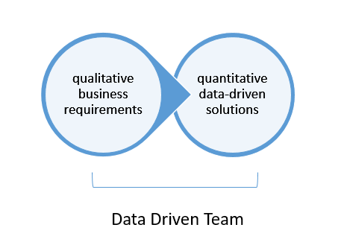
- You bump into a colleague in the hallway who you haven’t seen for a couple of weeks. She mentions she just returned from a popular international destination vacation. To know more about the destination, you ask her – “Wow! Is it really as exotic as they show in the magazines?”
- Your roommate got a new video game that he has been playing nonstop for a few hours. When he takes a break, you ask him – “Is the game really that cool?”
Did you find any of these questions ‘artificial’? Do re-read the scenarios and take a few seconds to think through. Most of us would find these questions to be perfectly natural!
What would certainly be artificial though is asking questions like:
- ‘Hey, was the movie direction 3.5-out-of-5?’, or
- ‘Is the vacation destination 8 on a scale of 1-to-10?’, or
- ‘Is the video game in the top 10 percentile of all the video games?’
In most scenarios, we express our asks in qualitative terms. This is true about business requirements as well.


This gap between qualitative business requirements and quantitative machine requirements is exacerbated when it comes to data-driven products.

A typical business requirement for a data-driven product could be “develop an optimal digital marketing strategy to reach the likely target customer population”. Converting this to a quantifiable requirement has several non-trivial challenges. Some of these are:
- How we define ‘optimal’: Do we focus more on precision or more on recall? Do we focus more on accuracy (is the approached customer segment really our target customer segment or not)? Or do we focus more on efficiency (how quickly do we make a go/no-go decision once the customer segment is exposed to our algorithm)?
- How do we actually evaluate if we have met the optimal criteria? And if not, how much of a gap exists?
To define customers ‘similar’ to our target population, we need to agree on a set of N dimensions that will be used for computing this similarity:
- Patterns in the browsing history
- Patterns in e-shopping
- Patterns in user-provided meta-data, and so on. Or do we need to device a few other dimensions?
After that, we need to critically evaluate whether all the relevant data exists in an accessible format. If not, are there ways to infer at least parts of it?

Is the Right Data Available with the Right Level of Granularity?
Consider a business scenario where a company has a chatbot that handles customer queries automatically. When the chatbot fails to resolve a customer query, the call is transferred to a human expert.
It is fair to assume that the cost of a human expert manning a call center is higher than an automated chatbot resolving the customer query. Thus, the business problem can be stated as: Reduce the proportion of calls that reach a human expert.

The first barrier to cross is often the HiPPO Effect.
Simply put, the HiPPO (Highest Paid Person’s Opinion) effect states that the authority figure’s suggestions are interpreted as the final truth, and promptly implemented, even if the findings from the data are contrary.
For instance, in the above example, the HiPPO might be that calls are getting diverted to human experts due to time-out issues related to network connectivity within the chatbot’s workflow. A more prudent data-driven approach would be to list out all the possible reasons leading to call diversions, one of them being the connectivity issue.
Such a list can be derived from a combination of expert knowledge and some initial data log analysis. This step falls under, what we call, the ‘data-discovery’ phase.
The data-discovery phase, which is essentially an iterative process, systematizes the use of insights from the data to guide the expert’s intuition and to identify the next dimension of data to investigate.
The data-discovery phase also identifies if there are any gaps in the ‘ideal-data-needed’ vs. ‘actual-data-available’. For example, we may identify that the last interaction between the chatbot and the customer is not being stored in the database. This lack of data needs to be solved promptly by changing the data storage schema.
Let’s assume that this analysis of possible failure scenarios led to the following findings:
- The chatbot did not understand the intent
- The chatbot is not able to establish a connection with the knowledge base
- The chatbot is not able to retrieve relevant information from the knowledge base before the time-out
- There is no relevant information in the knowledge-base, or
- Unknown/non-replicable issues
Armed with this information, the next step would be to dig deeper. For example:
- Is the intent not understood because the speech-to-text component failed or the text-to-intent mining component misfired?
- Is the time-out occurring because the information is not stored in the right format (e.g., suboptimal inverted index)? or
- Is the information not easily accessible (e.g., on an LRU cache vs in a network-call setup like ElasticSearch)? and so on
The findings from this step will help rank the problems in terms of their prevalence and also identify systemic issues. If the failure of the speech-to-text component is one of the prevalent problems, the speech-to-text vendor needs to be approached to identify if the speech inputs are not being captured/transferred as per the norms/best-practices or if the speech-to-text system needs more context for better predictions.

Repeatability and Reproducibility: Consistency in Labeled Data for Accurate AI Systems
One of the final steps is to have a relevant subset of data labeled by human experts in a consistent manner.
At the vast scale of Big Data, we are talking about obtaining labels for hundreds of thousands of samples. This will need a huge team of human experts to provide the labels.
A more efficient way would be to sample the data in such a manner that only the most diverse set of samples are sent for labeling. One of the best ways to do this is to use stratified sampling. Domain experts will need to analyze which data dimensions get used for the stratification.
Consistency in human labels is trickier than it may seem at first. If the existing automated techniques for label generation are 100% accurate, then there is no need for training any newer machine learning algorithms. And hence, there is no need for human-labeled training samples (e.g., we do not need manual transcription of speech if speech-to-text systems are 100% accurate).

At the same time, if there is no subjectivity in human labeling, then it is just a matter of tabulating the list of steps that the human expert has followed and automating those steps. Almost all practical machine learning systems need training because they are not able to adequately capture the various nuances that humans apply in coming to a particular decision.
Thus, there will be a certain level of inherent subjectivity in the human labels that can’t be done away with.
The goal, however, should be to design label-capturing systems that minimize avenues for ‘extraneous’ subjectivity.
For example, if we are training a machine learning system to predict emotion from speech, the human labels will be generated by playing the speech signals and asking the human labeler to provide the predominant emotion.
One way to minimize extraneous subjectivity is to provide a drop-down of the possible emotion label options instead of letting the human labeler enter his/her inputs in a free flow text format. Similarly, even before the first sample gets labeled, there should be a normalization exercise among the human experts where they agree on the interpretation of each label (e.g., what is the difference between ‘sad’ and ‘angry’).
An objective way to check the subjectivity is ‘repeatability and reproducibility (R&R)’. Repeatability measures the impact of temporal context on human decisions. It is computed as follows:
- The same human expert is asked to label the same data sample at two different times
- The proportion of the times the expert agrees with themselves is called repeatability
Reproducibility measures how consistently the labels can be replicated across experts. It is computed as follows:
- Two or more human experts are asked to label the same data samples in the same setting
- The proportion of the times the experts agree among themselves is called reproducibility
Conducting R&R evaluations on even a small scale of data can help identify process improvements as well as help gauge the complexity of the problem.

CONCLUSION:
By implementing this practical on live project student will be able to convert business problem into data science problem.

  - Business Problem statement:

  - Data Science Problem:

  - Data Availability: Yes or No

  - Data Available Form: Qualitative or Quantitative data (add Sample data print)
  - How Bridging the Qualitative-to-Quantitative Gap in your project:

  - Is the Right Data Available with the Right Level of Granularity?

  - Repeatability and Reproducibility: Consistency in Labeled Data for Accurate

Laboratory Report
Experiment No - 2
Batch -

Date of Experiment: __________ Date of Submission: __________

Title: ___________________________________________________________
Evaluation
1) Attendance [2] ----------------
2) Lab Performance [2] ----------------
3) Oral [1] ----------------

Overall Marks [5] ----------------

Subject Incharge

Experiment No. 2

TITLE: Apply agile methodology for project management and generate work breakdown sheet.

HARDWARE CONFIGURATION / KIT:
Sr. No | Hardware Configuration
1 | Processor | 1.5GHz or more
2 | RAM | 512 MB Minimum
3 | HDD | Minimum 900MB free Space
4 | Standard I/O devices | Basic Input Devices

SOFTWARE CONFIGURATION:
Sr. No | Software Configuration
1 | Operating System | Windows XP or later
2 | Jupyter Notebook

THEORY:
The Agile methodology is a project management approach that involves breaking the project into phases and emphasizes continuous collaboration and improvement. Teams follow a cycle of planning, executing, and evaluating.
Agile methodology is a project management framework that breaks projects down into several dynamic phases, commonly known as sprints.
The Agile framework is an iterative methodology. After every sprint, teams reflect and look back to see if there was anything that could be improved so they can adjust their strategy for the next sprint.
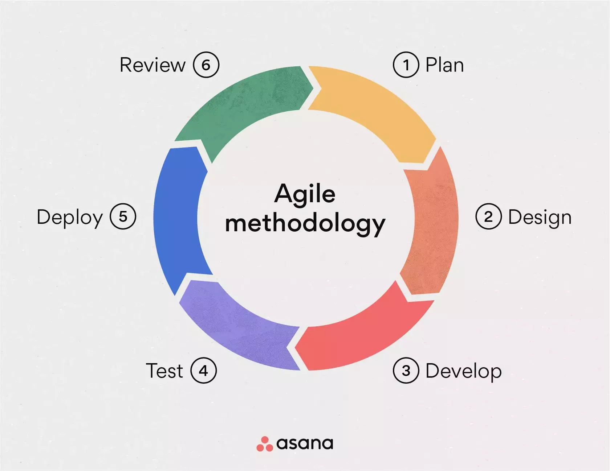

What is the Agile Manifesto?
The Agile Manifesto is a document that focuses on four values and 12 principles for Agile software development. It was published in February 2001 by 17 software developers who needed an alternative to the more linear product development process.

What are the 4 pillars of Agile?
As outlined in the Agile Manifesto, there are four main values of Agile project management:
- Individuals over processes and tools: Agile teams value team collaboration and teamwork over working independently and doing things "by the book.”
- Working software over comprehensive documentation: The software that Agile teams develop should work. Additional work, like documentation, is not as important as developing good software.
- Customer collaboration over contract negotiation: Customers are extremely important within the Agile methodology. Agile teams allow customers to guide where the software should go. Therefore, customer collaboration is more important than the finer details of contract negotiation.
- Responding to change over following a plan: One of the major benefits of Agile project management is that it allows teams to be flexible. This framework allows for teams to quickly shift strategies and workflows without derailing an entire project.

Examples of Agile Methodology
The most popular and common examples are Scrum, eXtreme Programming (XP), Feature Driven Development (FDD), Dynamic Systems Development Method (DSDM), Adaptive Software Development (ASD), Crystal, and Lean Software Development (LSD). Teams generally pick one or two methods. The most widely used methodologies are Scrum and XP, which dovetail nicely.

What are the 12 Agile principles?
The four values of Agile are the pillars of Agile methodology. From those values, the team developed 12 principles.
If the four values of Agile are the weight-bearing pillars of a house, then these 12 principles are the rooms you can build within that house. These principles can be easily adapted to fit the needs of your team.
The 12 principles used in Agile methodology are:
- Satisfy customers through early, continuous improvement and delivery.When customers receive new updates regularly, they're more likely to see the changes they want within the product. This leads to happier, more satisfied customers—and more recurring revenue.
- Welcome changing requirements, even late in the project. The Agile framework is all about adaptability. In iterative processes like Agile, being inflexible causes more harm than good.
- Deliver value frequently. Similar to principle #1, delivering value to your customers or stakeholders frequently makes it less likely for them to churn.
- Break the silos of your projects. Collaboration is key in the Agile framework. The goal is for people to break out of their own individual projects and collaborate together more frequently.
- Build projects around motivated individuals. Agile works best when teams are committed and actively working to achieve a goal.
- The most effective way to communicate is face-to-face. If you’re working on a distributed team, spend time communicating in ways that involve face-to-face communication like Zoom calls.
- Working software is the primary measure of progress. The most important thing that teams should strive for with the Agile framework is the product. The goal here is to prioritize functional software over everything else.
- Maintain a sustainable working pace. Some aspects of Agile can be fast-paced, but it shouldn't be so fast that team members burn out. The goal is to maintain sustainability throughout the project.
- Continuous excellence enhances agility. If the team develops excellent code in one sprint, they can continue to build off of it the next. Continually creating great work allows teams to move faster in the future.
- Simplicity is essential. Sometimes the simplest solution is the best solution. Agile aims to not overcomplicate things and find simple answers to complex problems.
- Self-organizing teams generate the most value. Similar to principle #5, proactive teams become valuable assets to the company as they strive to deliver value.
- Regularly reflect and adjust your way of work to boost effectiveness. Retrospective meetings are a common Agile practice. It's a dedicated time for teams to look back and reflect on their performance and adapt their behaviors for the future.

Work Breakdown Structure (WBS) Definition
The project management institute (PMI®) defines WBS as follows:
A WBS is a hierarchical decomposition of the total scope of work to be carried out by the project team to accomplish the project objectives and create the required deliverables.
The definition looks quite simple, but it’s a very significant statement for understanding the WBS. Let’s break it down.
- Hierarchical structure: The WBS is usually a hierarchical structure. It can present in a graphical format, tree form, or a tabular structure, but it will always be hierarchical in nature. The highest level of the WBS is known as Level-1 and followed with Level-2. It can continue to Level-N.
- Decomposition: The total scope of project work is considered and the team breaks down the work into manageable chunks. That’s why in the name WBS, we have a term breakdown. The decomposition or breakdown of the WBS creates the various levels, deliverables, and work packages. As you follow the breakdown, each descending level of WBS represents a further detailed definition of the work to be done.
- Deliverable: The deliverable is the unique, verifiable product, service, or result produced. The WBS is usually deliverable oriented when you do the decomposition. Based on the WBS, deliverables are created by the project team.
The previous statement of deliverable-oriented breakdown will enable us to understand how to actually break the project or program scope down to create the WBS.

Work Breakdown Structure (WBS) Examples
Let’s take, for example, the writing of a book. Say you are writing a book on risk management. You want to have deliverables in terms of “Manuscript,” “Write Book,” “Edit Book,” and finally, “Publish Book.” Under “Write Book,” you have the individual chapters to be written (Chapter 1, Chapter 2, and so on). Similarly, under “Edit Book,” you’ll want to edit the individual chapters. In such a case, the WBS would be represented as shown.
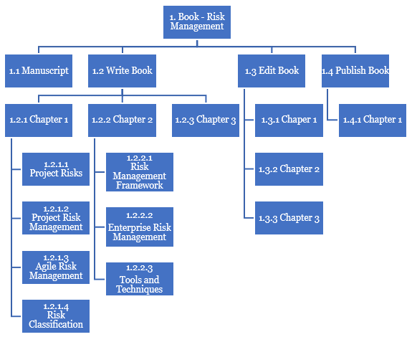
At the highest level, i.e., Level-1 (L1), we have the name of the book. In the next level, i.e., Level-2 (L2), we have the phases of writing, such as “Write Book,” “Edit Book,” and “Publish Book.” Next, “Write Book” is broken down into “Chapter 1,” “Chapter 2,” “Chapter 3,” and so also with the other WBS elements in levels. At the lowest level (L3), we have more details on each chapter (“Project Risk,” “Project Risk Management,” and “Agile Risk Management” and so on).
Agile development combines and leverages both iterative development with improved or optimized learning and incremental development with speed of delivery. This is depicted below.
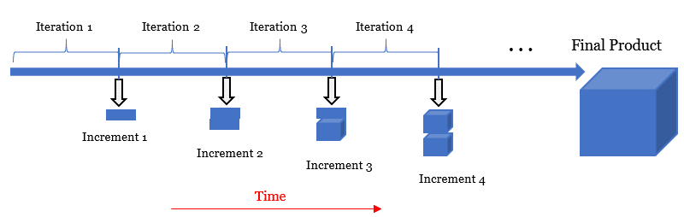

WBS in Predictive Life Cycle
In a predictive life cycle model, requirements are fully known, change is low, and risk is also low. Hence, the phases in a project can be sequentially executed, though the final product (or service or result) is delivered at the end of the final phase.
Taking our book example, one can say the following phases of the project create the book. (I’ve made the phases a bit more formal compared to the previous example.)
- Research
- Design
- Development
- Delivery
With the adoption of these phases, the WBS will become as is shown below.
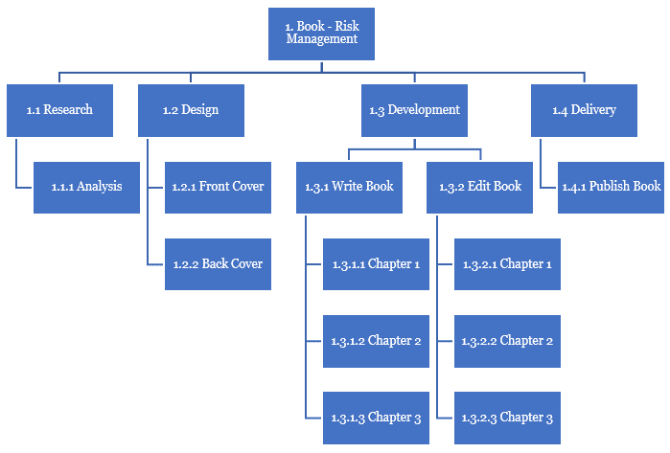
At L1, you have the project name, i.e., “Book – Risk Management.” At L2, you have the various phases. The level-2 elements of the WBS are further decomposed to finally give us the work packages:
- “1.2 Design” is broken down to “1.2.1 Front Cover” and “1.2.2 Back Cover.”
- “1.3 Development” is broken down to “1.3.1 Write Book” and “1.3.2 Edit Book,” which are further broken down to the individual chapter level.
With Microsoft Project as your tool, you create and plot the WBS quickly as I’ve shown in the next figure.
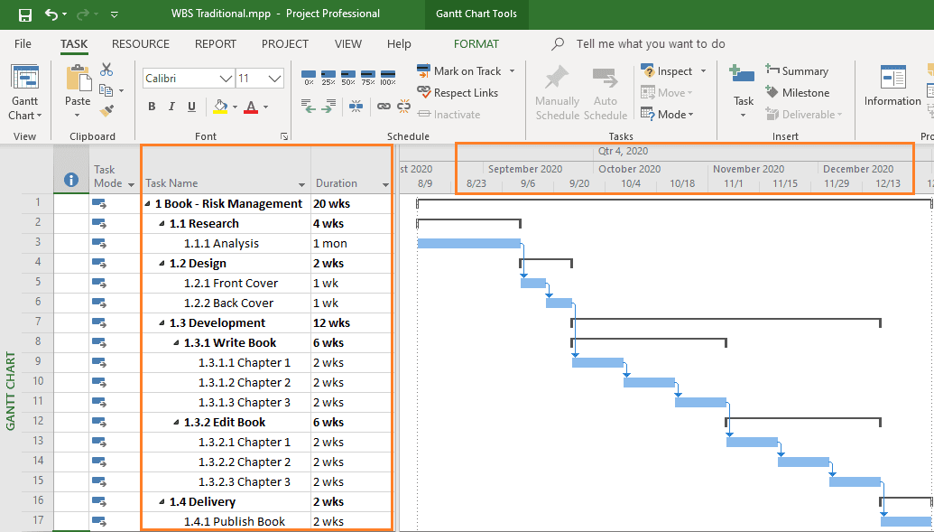

What is the scrum model?
Scrum is a framework for getting work done within agile. Scrum uses all the core principles of agile to define methods to facilitate a project. However, it is important to note that agile does not always mean Scrum. Many different methodologies take an agile approach to project management.

Scrum is the type of Agile framework. It is a framework within which people can address complex adaptive problem while productivity and creativity of delivering product is at highest possible values. Scrum uses Iterative process. Silent features of Scrum are:
- Scrum is light-weighted framework
- Scrum emphasizes self-organization
- Scrum is simple to understand
- Scrum framework help the team to work together
Lifecycle of Scrum:
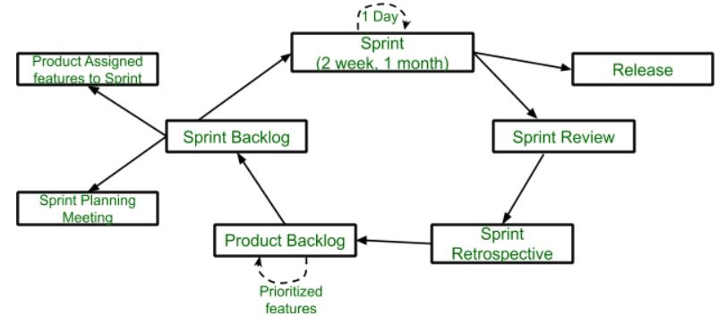
Sprint: A Sprint is a time box of one month or less. A new Sprint starts immediately after the completion of the previous Sprint. Release: When the product is completed, it goes to the Release stage. Sprint Review: If the product still has some non-achievable features, it will be checked in this stage and then passed to the Sprint Retrospective stage.
Sprint Retrospective: In this stage quality or status of the product is checked.
Product Backlog: According to the prioritize features the product is organized.
Sprint Backlog: Sprint Backlog is divided into two parts Product assigned features to sprint and Sprint planning meeting.

CONCLUSION:
By implementing this practical student will be able to apply agile methodology on project. Effectively use scrum model.

Note: Enclosed your own project work breakdown (Grant chart/ planning schedule).

Laboratory Report
Experiment No - 3
Batch -

Date of Experiment: __________ Date of Submission: __________

Title: ___________________________________________________________
Evaluation
1) Attendance [2] ----------------
2) Lab Performance [2] ----------------
3) Oral [1] ----------------

Overall Marks [5] ----------------

Subject Incharge

Experiment No. 3

TITLE: To create agile product backlog with sprint backlog.

HARDWARE CONFIGURATION / KIT:
Sr. No | Hardware Configuration
1 | Processor | 1.5GHz or more
2 | RAM | 512 MB Minimum
3 | HDD | Minimum 900MB free Space
4 | Standard I/O devices | Basic Input Devices

SOFTWARE CONFIGURATION:
Sr. No | Software Configuration
1 | Operating System | Windows XP or later
2 | Jupyter Notebook

THEORY:
What do you mean by scrum?
Scrum is a management framework that teams use to self-organize and work towards a common goal. It describes a set of meetings, tools, and roles for efficient project delivery. Much like a sports team practicing for a big match, Scrum practices allow teams to self-manage, learn from experience, and adapt to change.

What is a sprint?
Sprints are time-boxed periods of one week to one month, during which a product owner, scrum master, and scrum team work to complete a specific product addition. During a sprint, work is done to create new features based on the user stories and backlog.

Agile Methodology Tools
- ActiveCollab. An affordable tool for small businesses, ActiveCollab is easy to use. This software development aid requires little training and provides excellent support.
- Agilo for Scrum. Stakeholders get updated automatically on the project’s progress with Agilo for Scrum. Features sprint reports and burn down charts for better data mining.
- Atlassian Jira + Agile. This powerful project management tool facilitates development by incorporating Scrum, Kanban, and customizable workflows.
- Pivotal Tracker. This methodology tool is geared specifically for mobile projects. A little jargon-heavy, it’s user-friendly after a brief orientation period.
- Prefix. This free tool from Stackify provides an instant feedback loop to catch and fix bugs before they can deploy.
- Retrace. For a more robust solution complete with monitoring, errors, logs, and more, Stackify’s Retrace provides app performance insights from integration to QA to production, at the code level.

Additional Resources
Make use of the non-product style tools and resources for success below, including the original Agile manifesto and a few downloadable templates for implementation.
- Agile Manifesto. This is the original document that kicked off the Agile movement. It contains all 12 key tenets of the methodology at large.
- Burn Down Charts. These are visual representations of work left vs remaining time. Download an Excel template from SmartSheet.com.
- Agile project plan. This is a tool for tracking the progress of the overall Agile project. This from Ambysoft outlines the entire project planning process.
- Agile product backlog. This helps product owners track and prioritize customer requirements.

CONCLUSION:
By implementing this practical able to create agile product backlog and sprint backlog.

Note: Enclosed your own project product backlog and sprint backlog.

Laboratory Report
Experiment No - 4
Batch -

Date of Experiment: __________ Date of Submission: __________

Title: ___________________________________________________________
Evaluation
1) Attendance [2] ----------------
2) Lab Performance [2] ----------------
3) Oral [1] ----------------

Overall Marks [5] ----------------

Subject Incharge

Experiment No. 4

TITLE: To apply Data Preparation best practices on project.

HARDWARE CONFIGURATION / KIT:
Sr. No | Hardware Configuration
1 | Processor | 1.5GHz or more
2 | RAM | 512 MB Minimum
3 | HDD | Minimum 900MB free Space
4 | Standard I/O devices | Basic Input Devices

SOFTWARE CONFIGURATION:
Sr. No | Software Configuration
1 | Operating System | Windows XP or later
2 | Jupyter Notebook

What is Data Preparation?
Data preparation includes finding, combining, cleaning, transforming and sharing curated datasets for various data and analytics use cases. Data preparation is a must-have capability for organizations that are looking to accelerate time-to-insight from data through decentralized, self-service analytics. Increasingly diverse data, and the pressure to provide the right data to the right people at the right time, is driving this demand for data preparation capabilities. This is why data and analytics leaders must integrate data preparation into their overall data management strategy.
Data preparation is usually a manual, time-consuming process but using advanced analytics tools with effective data preparation capabilities can significantly automate the process, freeing up time for analysis of the prepared data. Data preparation tools deliver faster time to insight by allowing business users including analysts, citizen integrators, data engineers and citizen data scientists to integrate internal and external datasets for their use cases. Additionally, they enable users to identify anomalies and patterns faster and improve and review the data quality of their findings by automating certain repeatable data preparation tasks.

Data Preparation Best Practices:
Data preparation is a critical aspect of data management and by allowing business users to prepare their own data for analysis, organizations can reduce reliance on IT, accelerate time-to-insight, and enhance decision-making. Here are a few best practices to effectively prepare your data for actionable analysis.

1. Build a Robust Data Governance Strategy
Data governance is essential because it helps you define the standards that your data preparation efforts must meet. Data must be seen as a strategic asset for your business and stakeholders must own and be accountable for data governance efforts. Data governance should focus on business value and outcomes, and must be aligned with achieving specific business priorities. The scope and accountability must be assigned by key stakeholders in the organization, and must be documented and routinely reviewed. This helps you clearly understand where your data and analytics assets are created, consumed and controlled, and will better assure business stakeholders that the right governance processes and controls are in place.

2. Ensure Good Data Quality
Resolving data quality issues requires a collective approach that involves people, governance, processes and technologies as key factors. Data and analytics leaders must collaborate with business stakeholders to build a data quality operating model that enables you to allocate the appropriate resources and improve the skills, technology, and processes required to implement your data quality program.

3. Verify the Accuracy of Your Data
Get to know your data before you prepare it for analysis. Examine, visualize, detect outliers, and find inaccurate or junk data in your data set. This can help you decide if the data source is worth including in your project. Disqualifying a data source early on in your project can help you save significant effort later on in trying to clean up inaccurate data. If your data source is good enough and you want to include it, this exercise can help you understand the ETL effort needed to make this data suitable for analysis.

4. Identify Outliers and Missing Values
Identify the data points that are out of sync with the rest of your data. These are called outliers and are either very small or very large values when compared with the rest of the dataset. Outliers or missing values can compromise your analytics processes because they can have a huge impact on your mean values. When faced with outlets, you can run your analytics twice – once with outliers included and once with them excluded and evaluate which method suits your needs better.

5. Start with Small Data Sets
Working with large data sets can be cumbersome and tedious. You should always start with a sample of your data for initial analysis and data preparation. Creating data preparation rules based on a smaller data set greatly simplifies the process and accelerates your time-to-insight.

What Are the Different Data Collection Methods?
Primary and secondary methods of data collection are two approaches used to gather information for research or analysis purposes. Let's explore each data collection method in detail:

1. Primary Data Collection:
Primary data collection involves the collection of original data directly from the source or through direct interaction with the respondents. This method allows researchers to obtain firsthand information specifically tailored to their research objectives. There are various techniques for primary data collection, including:
a. Surveys and Questionnaires: Researchers design structured questionnaires or surveys to collect data from individuals or groups. These can be conducted through face-to-face interviews, telephone calls, mail, or online platforms.
b. Interviews: Interviews involve direct interaction between the researcher and the respondent. They can be conducted in person, over the phone, or through video conferencing. Interviews can be structured (with predefined questions), semi-structured (allowing flexibility), or unstructured (more conversational).
c. Observations: Researchers observe and record behaviors, actions, or events in their natural setting. This method is useful for gathering data on human behavior, interactions, or phenomena without direct intervention.
d. Experiments: Experimental studies involve the manipulation of variables to observe their impact on the outcome. Researchers control the conditions and collect data to draw conclusions about cause-and-effect relationships.
e. Focus Groups: Focus groups bring together a small group of individuals who discuss specific topics in a moderated setting. This method helps in understanding opinions, perceptions, and experiences shared by the participants.

2. Secondary Data Collection:
Secondary data collection involves using existing data collected by someone else for a purpose different from the original intent. Researchers analyze and interpret this data to extract relevant information. Secondary data can be obtained from various sources, including:
a. Published Sources: Researchers refer to books, academic journals, magazines, newspapers, government reports, and other published materials that contain relevant data.
b. Online Databases: Numerous online databases provide access to a wide range of secondary data, such as research articles, statistical information, economic data, and social surveys.
c. Government and Institutional Records: Government agencies, research institutions, and organizations often maintain databases or records that can be used for research purposes.
d. Publicly Available Data: Data shared by individuals, organizations, or communities on public platforms, websites, or social media can be accessed and utilized for research.
e. Past Research Studies: Previous research studies and their findings can serve as valuable secondary data sources. Researchers can review and analyze the data to gain insights or build upon existing knowledge.

Data Collection Tools
Now that we’ve explained the various techniques, let’s narrow our focus even further by looking at some specific tools. For example, we mentioned interviews as a technique, but we can further break that down into different interview types (or “tools”).

Word Association: The researcher gives the respondent a set of words and asks them what comes to mind when they hear each word.

Sentence Completion: Researchers use sentence completion to understand what kind of ideas the respondent has. This tool involves giving an incomplete sentence and seeing how the interviewee finishes it.

Role-Playing: Respondents are presented with an imaginary situation and asked how they would act or react if it was real.

In-Person Surveys: The researcher asks questions in person.

Online/Web Surveys: These surveys are easy to accomplish, but some users may be unwilling to answer truthfully, if at all.

Mobile Surveys: These surveys take advantage of the increasing proliferation of mobile technology. Mobile collection surveys rely on mobile devices like tablets or smartphones to conduct surveys via SMS or mobile apps.

Phone Surveys: No researcher can call thousands of people at once, so they need a third party to handle the chore. However, many people have call screening and won’t answer.

Observation: Sometimes, the simplest method is the best. Researchers who make direct observations collect data quickly and easily, with little intrusion or third-party bias. Naturally, it’s only effective in small-scale situations.
Key performance indicators:
KPI is an abbreviation for key performance indicator, data that has been collected, analyzed, and summarized to help decision making. KPIs may be a single calculation or value that summarizes a period of activity, such as “450 sales in the month of October.” By themselves, KPIs do not add any value to a company. However, a company can use this information to make more informed decisions about business operations and strategies.

What is an example of a KPI?
One of the most basic examples of a KPI is revenue per client (RPC). For example, if you generate $100,000 in revenue annually and have 100 clients, then your RPC is $1,000. A company can use this KPI to track its RPC over time.
Business stake holders dashboard or Visualization:
A dashboard is a type of graphical user interface that often provides at-a-glance views of key performance indicators relevant to a particular objective or business process of pos.
CONCLUSION:
By applying Data Preparation best practices on project able to identify suitable data for problem, identify Key Performance Indicators (KPI’s) and show visualization of analysis.

  - Problem Statement:

  - Data Created or Collected for project:

  - Display sample data:

  - Show Key Performance Indicators (KPI’s) in your mentioned project:

  - Show Visualization or create Dashboard

Note: Enclosed Sample data, Program and visualization or dashboard.

